1. 
2. Department of Computer Science and Engineering
3. Walchand College of Engineering, Sangli
4. **Mini Project**
5. Smart Class : Data Structures
6. T.Y in Computer Science and Engineering
7. Project Members

|  |  |  |  |
| --- | --- | --- | --- |
| Roll No. | | Name | Exam Seat No. |
| 072 | Bobade Suraj A. | | (2013BCS072) |
| 048 | Tayde Sarang G. | | (2013BCS048) |
| 065 | Selokar Mrunal k. | | (2013BCS065) |
|  |  | |  |

1. **Project Guide**
2. *Prof. A. R. Surve*
3. **Academic Year**
4. *2015-2016*

## 

1. Department of Computer Science and Engineering
2. Walchand College of Engineering, Sangli

# CERTIFICATE

This is to certify that the Third year B.Tech. Project entitled “Smart Class: Data Structures” submitted by ------------------------for the partial fulfillment of the requirement for the award of the degree of Bachelor of Computer Science and Engineering of the Walchand College of Engineering, Sangli is a bonafide work carried out during academic year 2015-16.

Head of Department

Guide C.S.E.

Examiner(s)

1.________________

2.________________

Date:

Place:

**ACKNOWLEDGEMENT**

We wish to take this opportunity to express our deep gratitude to all the people who have extended their cooperation in various ways during my project work. It is our pleasure to acknowledge the help of all those individuals.

We would like to thank our project guideProf A. R. Surve sir, Asst.Prof, Computer Science and engineering Department for his guidance and help throughout the development of this project work by providing us with required information. With his guidance, cooperation and encouragement we had learnt many new things during our project tenure.

We specially thankDr. B. F. Momin, Head, Computer Science and Engineering Department for his continuous encouragement and valuable guidance in bringing shape to this dissertation.

We specially thank Dr. G.V Parishwad, Director of Walchand College of Engineering Sangli for his encouragement and support.

In completing this project successfully all our faculty members have given an excellent cooperation by guiding us in every aspect. We also thank our lab faculty and librarians.

Bobade Suraj A. [2013BCS072]

Tayde Sarang G. [2013BCS048]

Selokar Mrunal k. [2013BCS065]

Date:

Place: Walchand College of engg, Sangli

**INDEX**

* Introduction
* Purpose
* Scope of project
* references
* Overall description
* Product perspective
* Product functions
* UML diagrams
* System requirements
* User Interface
* Hardware Interface
* Software Interface
* System testing
* Unit Testing
* Integration Testing
* User Acceptance Testing
* Implementation
* User Training
* Security and Maintenance
* Conclusion
* Bibliography

**ABSTRACT**

Data structures are used in almost every program or software system. Specific data structures are essential ingredients of many efficient algorithms, and make possible the management of huge amounts of data, such as large integrated collection of databases. Some programming languages emphasize data structures, rather than algorithms, as the key organizing factor in software design.

For a student or a programmer it is necessary to visualize the data structure, understand what the data structure looks like and how it is structured both in the abstract and physically in the computer’s memory.

To master the data structures, one needs to be strong with both the theory and implementation of various Data Structures and Algorithms. As the complexity level of the problems increases, it becomes more difficult for the students to visualize and understand the things

So, this project intends to clarify the basic ideas of students regarding all types of data structures. The simple and noble aspiration behind the Smart Class application is to enhance the way of user friendly learning for the students by presenting the basic concepts of data structures in simple, easy and efficient way. The application describes each data structure and algorithm in a step-by-step manner.

The use of this application will provide following benefits

* + - Cover all the data structures
    - Clear description of the basics of the data structures
    - Complete visualization of all elements
    - Ease to handle data

In addition to these features, we would be inculcating a facility for sharing the theory with others. This will be benefitting for multiple users.

**List of figures**

* Activity Diagram
* Class Diagram
* Sequence Diagram
* Use Case Diagram-
* Use case For User
* Use Case Of System
* Use case of the database

**CHAPTER 1**

**INTRODUCTION**

* 1. **Purpose**

The simple and noble aspiration behind the Smart Class application is to enhance the way of user friendly learning for the students by presenting the basic concepts of data structures in simple, easy and efficient way.Its purpose is to visualize the data structures. Intuitively make the students understand what the data structure looks like and how it is structured both in the abstract and physically in computer’s memory. The application provides all the basic data structures, their description and the visualization of the constructs in step by step manner which aims at better understanding of the concepts of data structures.

**1.2 Scope of project**

The Smart Class application covers all the basic data structures as well as the major algorithms in computer programming which are also applicable in real life.

The application enlists all the basic data structures. All the data structures are provides with their subtypes. Each subtype is explained with its brief description. For every subtype, provision of inserting the input is provided which is then outputted in visual format of diagrams and pictures. The diagrams drawn cover all the details of the corresponding entries, for example, the one dimensional array is inputted and it is displayed as I the index of the entry, its value and the address in the database.

The Smart Class application is compatible within the wide range of Android versions ranging from 4.2.2 (sdk version 14) to 6.0 (sdk version 23).---–––

This android application follows the google standards to build an android application and the standard colour schemes. The interface of this application is user friendly so as to ease the access of the users to the application.

**1.3 References**

* stackoverflow.com
* androidhive.com
* design.google.com
* developers.android.com
* color.co

**CHAPTER 2**

**OVERALL DESCRIPTION**

**2.1 Product perspective**

The aim of this application is to let students know the basics of data structures and to visualize them how the data structures actually work. The application mainly focuses on clarifying the concepts of the students related to the data structures and its components.

* 1. **Product Functions**

The Smart Class application has a very simple working. It stores a list of all the Data Structures and algorithms. Each Data Structure has its subtypes with it. Upon selecting a subtype, the application shows two sections: Read Theory and implementation section.

**User Panel**

***Home***

1. This consist of List of Data Structures and the algorithms.

2. It contains a header which says to choose a data structure.

3. It also contains a button to share the current page details.

4. Each entry in the list, on selecting, displays a dropdown list of its subtypes.

5. On selecting a subtype, we are redirected to another screen.

6. On the top of the home screen there are two items:

Help and about section. Help section contains the knowledge about how to use app. About section contains the developer information of the application.

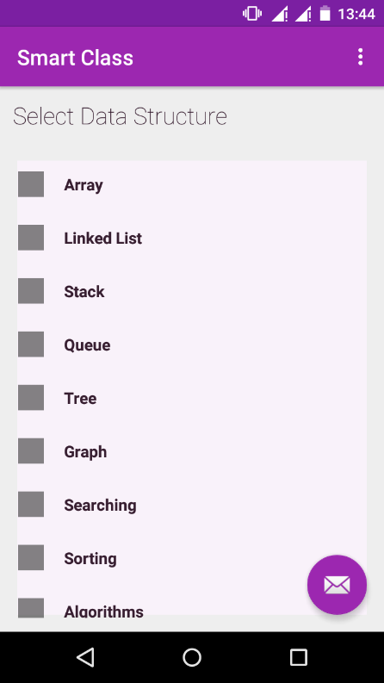 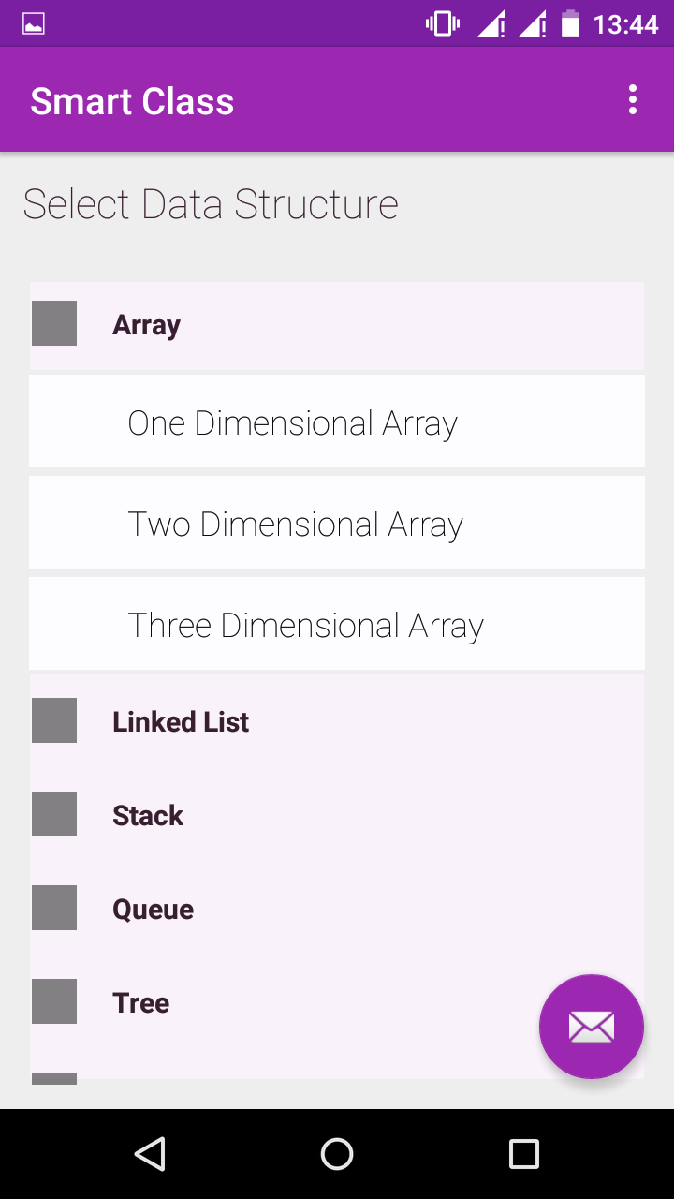

**(a)** *Home Screen (b) dropdown list*

***Subtype activity screen***

1. This screen consists of read theory section, summary section, input section and result section.
2. The read theory section goes to another screen.
3. In the bottom of this activity screen there is a section which asks for the input.
4. The result is displayed in the middle portion of the screen.
5. There is also a button to refresh the screen which clears all the contents of present activity and restarts the activity.

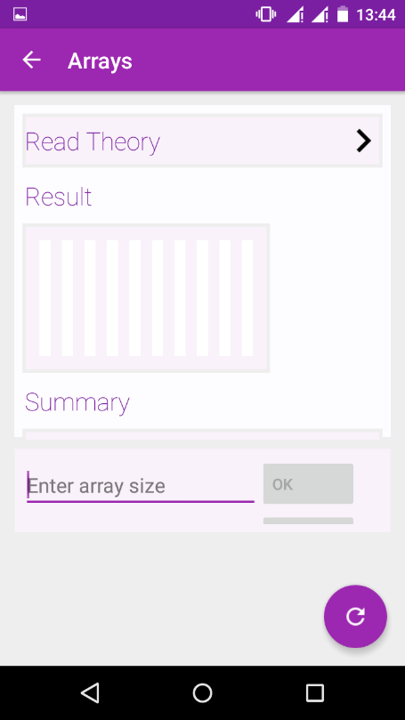 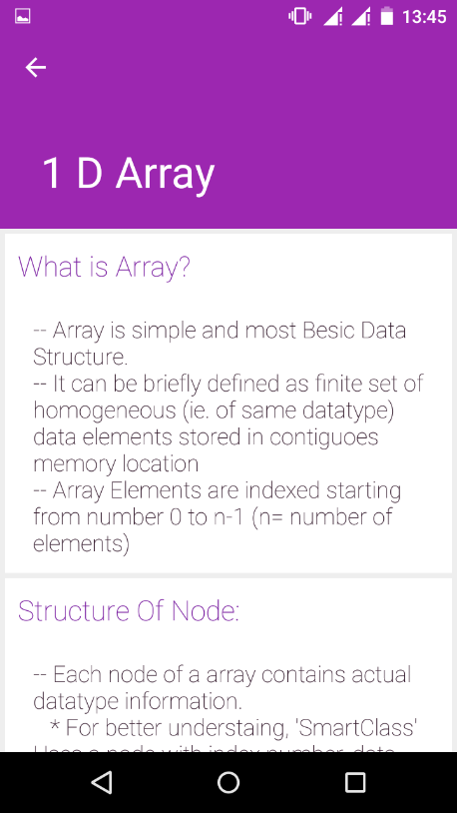

*(a)Subtype activity (a-1) read theory section*

* The input section displays the input panel.
* On pressing the “OK” button, the entry is updated in the diagram
* The diagram shows the exact position of the number in the corresponding data structure.

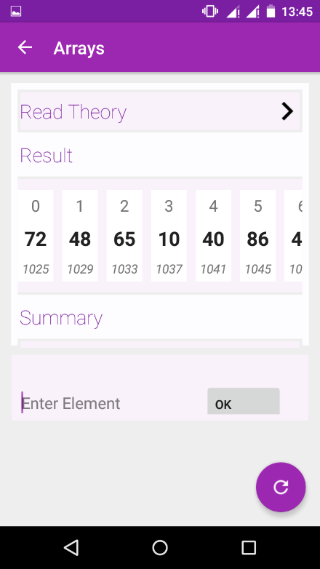

*(a-2) input section*

**2.3 UML DIAGRAMS**

UML stands for Unified modelling language. The UML diagram are mandatory for a programmer to understand the project thoroughly. UML diagrams include static diagrams and the interaction diagrams.

Here we have described the major UML diagrams for the Smart Class application.

1. **Class Diagram**

* Class diagram is a static diagram.
* It includes classes and relationships between them.
* The classes are shown by boxes which are partitioned into three sections: Class name, attributes and functions.
* The relationships between classes are shown by arrows. The arrows can be named to give more details of the type of relationship.

# 

This class diagram contains three classes: user, application and database.

*User class*: This class has operations selectAlgo / selectDataStructure, giveInput, etc.

*Application Class*: This class has attributes algorithm, dataStructures and the operations compute and display.

*Database Class*: This class stores input values as attributes and has functions store and synchronize.

The user and application class have ‘runs’ relationship from user to the application.

The application and database class have maintains relationship from application to the database.

1. **Activity diagram**

* Activity diagram is basically a flow chart to represent the flow form one activity to another activity.
* The activity can be described as an operation of the system.
* So the control flow is drawn from one operation to another. This flow can be sequential, branched or concurrent.
* Activity diagrams deals with all type of flow control by using different elements like fork, join etc.

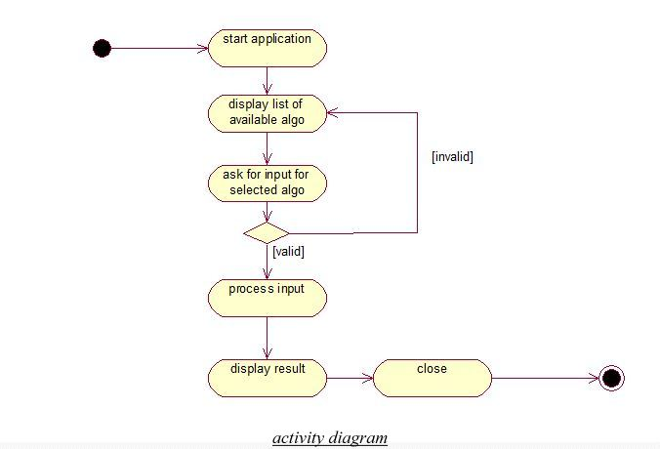The flow of this diagram is as follows:

* The user starts the application.
* The application then displays a list of data structures and algorithms to the user.
* The user selects the option from the list. The data structure is then expanded to its subtypes.
* Upon selecting the subtype, it asks for the input. If the input is valid, it proceeds or re-asks for the input.
* The application processes the input and displays the output diagram in the result section.

1. **3. Sequence diagram**

Sequence diagrams are interaction diagrams. Following things are to be identified clearly before drawing the sequence diagram:

* Objects taking part in the interaction.
* Message flows among the objects.
* The sequence in which the messages are flowing.
* Object organization.

The sequence diagram has lifeline for each participant and the sequence of messages among them.

Messages are shown by lines and responses are shown by dotted lines.

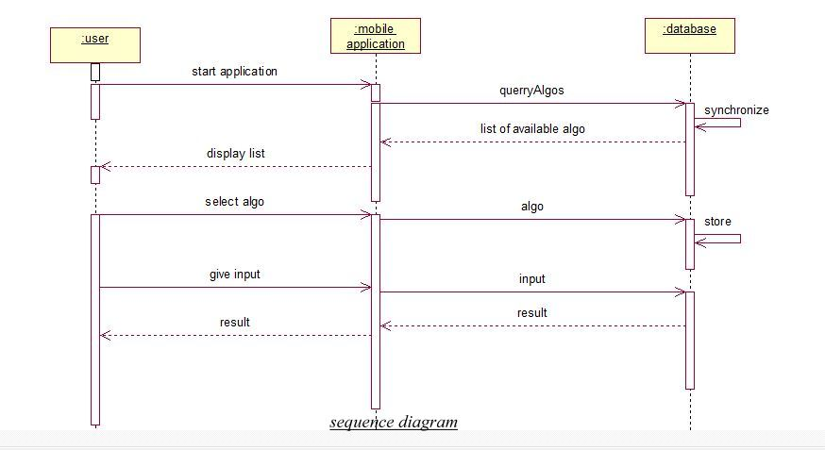

In this diagram the sequence of messages flows like this:

* + User starts the application. The application then queries for the available algorithms to the database. The database synchronizes within it and sends the list of available data structures and algorithms to the application. The application then displays the list to the user. The user then selects a data structure or algorithm which is sent form application to the database. The database stored the input within it. The user then enters the data to be inputed which is sent to the database. The application computes the result. The result is then displayed to the user.

**4.Use case diagrams:**

* + The use case diagrams are interaction diagrams.
  + The diagrams are composed of the actors and use cases.
  + The actors are shown by the symbol:-

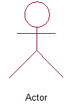

* The use cases are shown by the symbol:

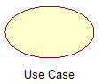

* The use cases are connected to the actors by arrows:

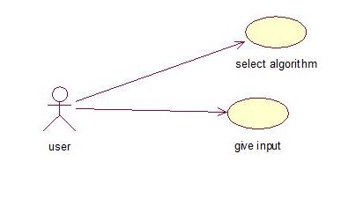

* + - 1. **Use cases of user.**

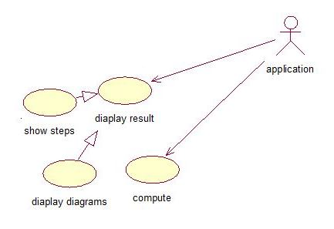

* + - 1. **Use cases of application**

**CHAPTER 3**

**SYSTEM REQUIREMENTS**

**User Interface:**

The Smart Class application is an android application. It provides a very clear and simple user interface. The interaction of user with the system has no complex factors as the application is completely user friendly. As all the android users are comfortable with the view of the android interface, the handling of Smart Class application is much easier.

**Hardware Interface:**

The Smart Class application is an android application. Hence it can run only on the android platform, i.e. , the systems supporting the android platform..

**Software interface:**

The Smart Class application is an android application which runs on a very wide range of android sdk versions.

The supportable android versions are as follows:

Min. supportable version: 4.2.2 (sdk version 14)

Max. Supportable version: 6.0 (sdk version 23)

**CHAPTER 4**

**SYSTEM TESTING**

System testing is the stage of implementation, which is aimed at ensuring that the system works accurately and efficiently before live operation commences. The ultimate aim is quality assurance. Tests are carried out and the results are compared with the expected document. In the case of erroneous results, debugging is done. Using detailed testing strategies a test plan is carried out on each module. The various tests performed are unit testing, integration testing and user acceptance testing.

**4.1 Unit Testing**

The software units in a system are modules and routines that are assembled and integrated to perform a specific function. Unit testing focuses first on modules, independently of one another, to locate errors. This enables, to detect errors in coding and logic that are contained within each module. This testing includes entering data and ascertaining if the value matches to the type and size supported by java. The various controls are tested to ensure that each performs its action as required.

**4.2 Integration Testing**

Data can be lost across any interface, one module can have an adverse effect on another, sub functions when combined, may not produce the desired major functions. Integration testing is a systematic testing to discover errors associated within the interface. All the modules are combined and tested as a whole.

**4.3 User Acceptance Testing**

User acceptance of a system is the key factor for the success of any system. The system under

Consideration is tested for user acceptance by constantly keeping in touch with the system users at time of developing and making changes whenever required.

**CHAPTER 5**

**IMPLEMENTATION**

Implementation is the stage in the project where the theoretical design is turned into a working system and is giving confidence on the new system for the users that it will work efficiently and effectively. It involves careful planning, investigation of the current system and its constraints on implementation, design of methods to achieve the changeover, an evaluation of change over methods.. The implementation process begins with preparing a plan for the implementation of the system. In **Smart Class Application**, no additional resources are needed. Implementation is the final and the most important phase.. The system can be implemented only after thorough testing is done and if it is found to be working according to the specification.

**5.1 User Training**

After the system is implemented successfully, training of the user is one of the most important subtasks of the developer. For this purpose user manuals are prepared and handled over to the user to operate the developed system. In order to put new application system into use, the following activities were taken care of:

· Preparation of documentation

. Conducting user training with demo and hands on

**5.2 Security and Maintenance**

Maintenance means restoring something to its original condition. Maintenance follows conversion to the extent that changes are necessary to maintain satisfactory operations relative to changes in the user’s environment. Maintenance often includes minor enhancements or corrections to problems that surface in the system’s operation. Maintenance is also done based on fixing the problems reported, changing the interface with other software or hardware enhancing the software.

Any system developed should be secured and protected against possible hazards. Security measures are provided to prevent unauthorized access of the database at various levels.

**CONCLUSION**

To conclude the description about the project: The project, developed using **Android studio version 1.4.1.** It is based on the requirement specification of the, with flexibility for future enhancement. The expanded functionality of today’s software requires an appropriate approach towards software development. This Smart Class application is designed for people who want to understand the basic concepts of data Structures thoroughly.

As the difficulty level or the complexity of the data structures increases, it becomes difficult for us to visualize the things. It is necessary for a developer to know how exactly the data is stores so as to choose the efficient data structure for the program.

This particular project deals with the problems on visualizing the structures and avoids the problems which occur when carried manually. Identification of the drawbacks of the existing ways to study data structures leads to the designing of the android application that will be compatible to the existing system with the system which is more user friendly and more GUI oriented.

**BIBLIOGRAPHY**

* developers.android.com
* stackoverflow.com
* androidhive.com
* design.google.com
* coolor.co